Simulink Installation and Running Simulations

Brandt Reutimann

6/6/2020

Manual Available at: <https://docs.google.com/document/d/13TN4Q6nLvoJRbVnZflQ68tQnjSQGGw4NT3vJh9E6-Cs/edit?usp=sharing>

**Table of Contents**

**What is Simulink?** **2**

**Installing Matlab and Simulink** **3**

**Running a Basic Simulation** **8**

Getting Oriented: 8

Running Experiment 1: 8

**Setting Up the Simulink Interface For Experiment 1** **12**

**Understanding the Controller and .YAML Specifications** **15**

Understanding Controllers: 15

Creating your own .YAML files for your Simulations 16

**Modifying Simulink Models to Create Your Own Simulations** **18**

Turning on Simulation Logging and Operating Points 19

Adding Blocks from the Gas Library 20

Simulink Network Sensor 21

Networked Setter 22

Sim Real Timer Recorder 23

Physical Network Pressure Sensor 24

Real Pressure Temperature 24

Pipeline 25

Load 25

Externally Controlled Load 26

Load Distributor 27

Valves 28

Compressors 28

Editing the “Mask” 30

Understanding the Configurations of load and line parameters 32

Gas Line Parameters 33

Gas Load Parameters 33

Valve Parameters 36

Telling the Simulations which table values to use: 36

# What is Simulink?

Simulink is a Matlab based modeling software that is capable of simulating complex physical systems such as electrical grids, gas pipes, or really any physical dynamics that can be mathematically represented. It’s primarily a tool for engineers to study the nature of certain systems using simulation. For example, a walk-through example in the Simulink tutorial has you design a system for modeling a bird diving and then opening its wings. This is represented with some math representing drag, velocity, and some other physics. We use Simulink as a tool for modeling gas systems in our SCADA simulation work. However, Simulink is just one component of the Simulation stack. There are several libraries like Simscape and the SCADA engineering toolbox that allow us to connect to virtual controllers and provide premade Simulation blocks.

Simulink is a visual block-based language. What this means is that whenever you are building new simulations you will be dragging, dropping, and connecting components. This block-based language is tightly coupled with MATLAB scripting so that MATLAB can be used to run simulations or set up initial states. For the use of our gas model, you will be primarily using and designing blocks from a library of gas blocks our team has already designed. Your workflow, then, will mainly be something like adding a new block from the library, adding it’s initialization code in the MatLab script, and connecting it to other blocks in the simulation. This manual will discuss how to install MATLAB/Simulink, how to run simulations, and how to build your own models based on our library of gas simulation blocks. Finally, we will also discuss how to set up your simulations so that they link up with the Simulink interface.

# Installing Matlab and Simulink

Matlab and Simulink are not open source, so the process of getting the software and licenses can be a little challenging. But it’s not too bad if you have your CSU student email.

1. The first thing to do is to visit the MATLAB for Students Link
   1. <https://www.mathworks.com/products/matlab/student.html>
   2. Click on the button that says “Check For Access”



1. The next thing to do is input your student email and university name

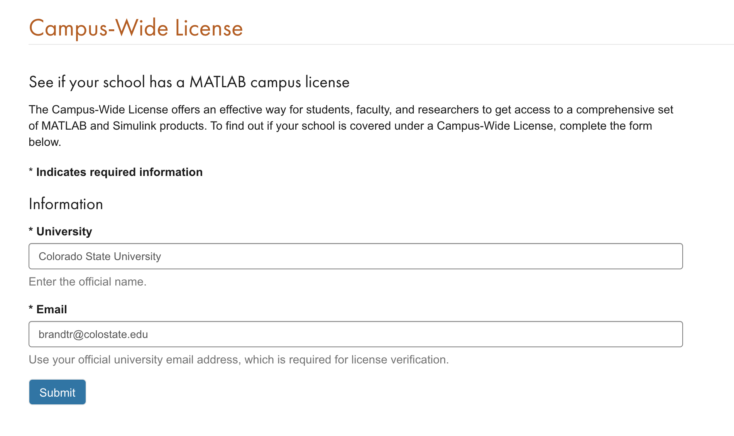

1. You should receive an email from Mathworks at your CSU student account

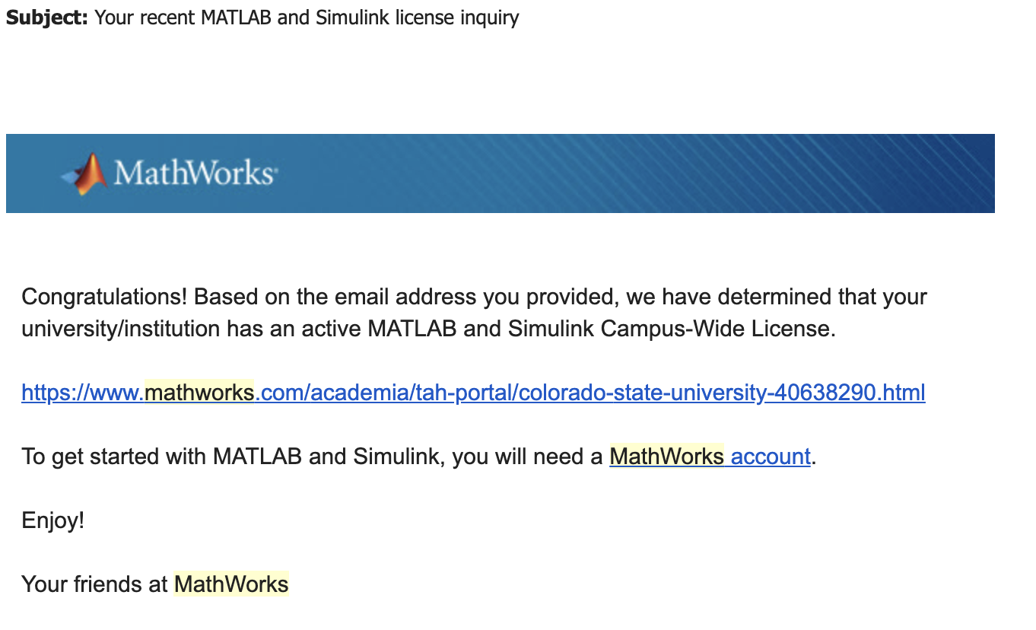

1. Follow the link in the email to get to the Colorado State Mathworks Page
   1. From here you’ll have to click “Sign and Get Started” which will take you to the classic CSU authentication page

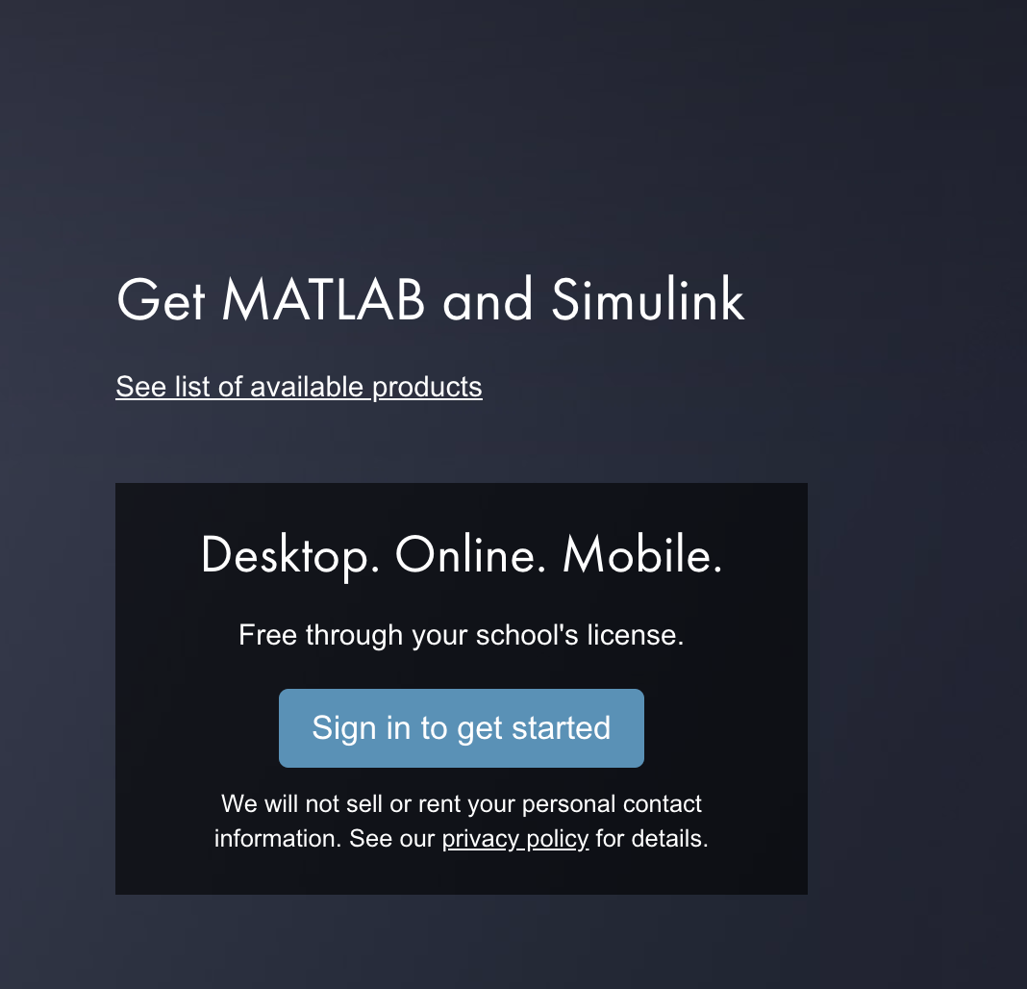



1. You will likely have to create a Mathworks account once you authenticate with CSU
   1. Once this is done you’ll finally be redirected to the downloads page
   2. As of writing this, the current version of MATLAB used in the Simulation is 2019b, however, 2020a should work fine.

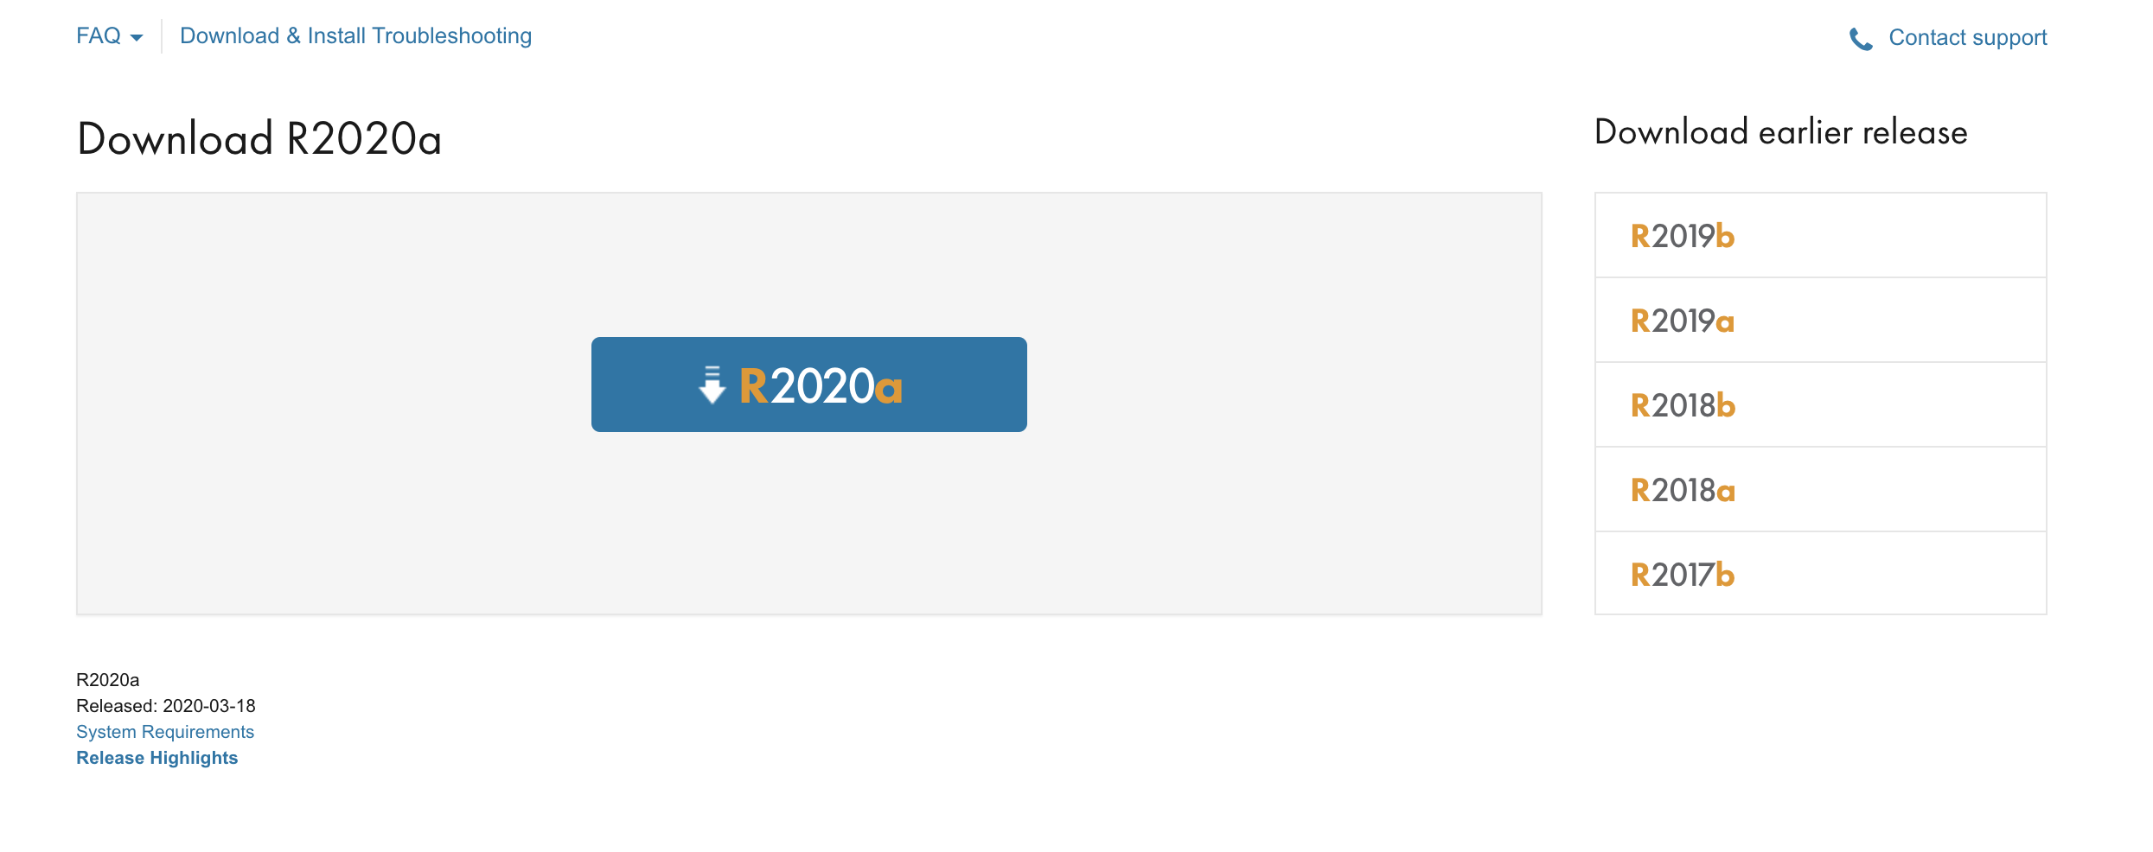

1. Once you’ve got the proper release for you OS, download the MATLAB installer and run it
   1. You’ll have to login again with your MathWorks account
   2. Accept the license agreement
   3. You should only see one license for your CSU account, use that one
2. You’ll eventually get to a package selector
   1. As of writing this, I can’t remember the exact packages but you’ll probably want the following
      1. MATLAB
      2. Simulink
      3. Control System Toolbox
      4. Instrumental Control Toolbox
      5. Simscape
      6. Simscape Electrical
      7. Simscape Fluids
      8. Simulink Control Design
      9. Symbolic Math Toolbox
   2. It also may be worth it to get the Simulink and MATLAB coders/SDKs and stuff

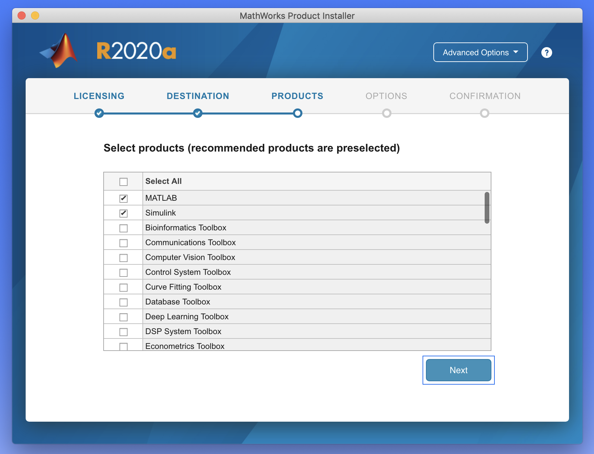

1. This will bring you to a confirm selections page where you can begin the download and install
   1. You can always come back and install other packages if you missed any
   2. This will probably take a while, the packages I selected showed about 12 GB of software

# Running a Basic Simulation

### Getting Oriented:

All code for our project is available on our [Github](https://github.com/BrandtRobert/SCADAVirtualization) project page. To download the source review the basics of git. Mainly you will want to clone the project. The Github project has 3 major top-level directories: controller, frontend/SCADA, and model. The simulation source code and files are available in model/simulinkmodel. To open these files you can right-click on any of the .slx or .m files and use “Open with MATLAB”. This should open up MATLAB, which should promptly request to change the working directory to the one for the current file. Approve of that change so that MATLAB is working within the Simulink working directory.

To run simulations for our gas model you have to be aware of the two basic file types in the Matlab explorer: *.m and *.slx. The *.m files are MATLAB scripts, these are snippets of MATLAB code that in our case is used to set up and run certain Simulations. The *.slx are simulation files. These files are the actual model that will be simulated. The *.slx files can be edited by moving blocks around. Finally, you may see *.slxc these are model cache files. It’s best to try and avoid deleting these.

### Running Experiment 1:

The first experiment you will want to run is experiment 1. This is a basic model with a single load and a single compressor. It’s a great place to start so that you can learn to run a simulation and you can tweak the model by adding more loads, pipes, or anything else.

1. To start with select experiment1.m in the MATLAB file explorer.
2. Next, select the editor tab in the top bar.
3. To run this initialization script you can click the run button in the top bar.
   1. Alternatively, it can be run by typing “experiment1” into the command window
   2. There will be several warnings in the command window. These have to do with the fact that not every output on every part of the simulation is connected. This isn’t a big deal as we can always add that later if we want to collect more data.
4. After running the script you may see the simscape results explorer pop up, this is because the model is configured to open up the results explorer after it runs.
   1. It is important to run these initialization scripts because they put the simulation into a state that it can start running without failing.
   2. If you skip initialization then sometimes the model will fail to solve its equations. This has to do with the fact that math can’t be solved easily when there are too many changes at once.

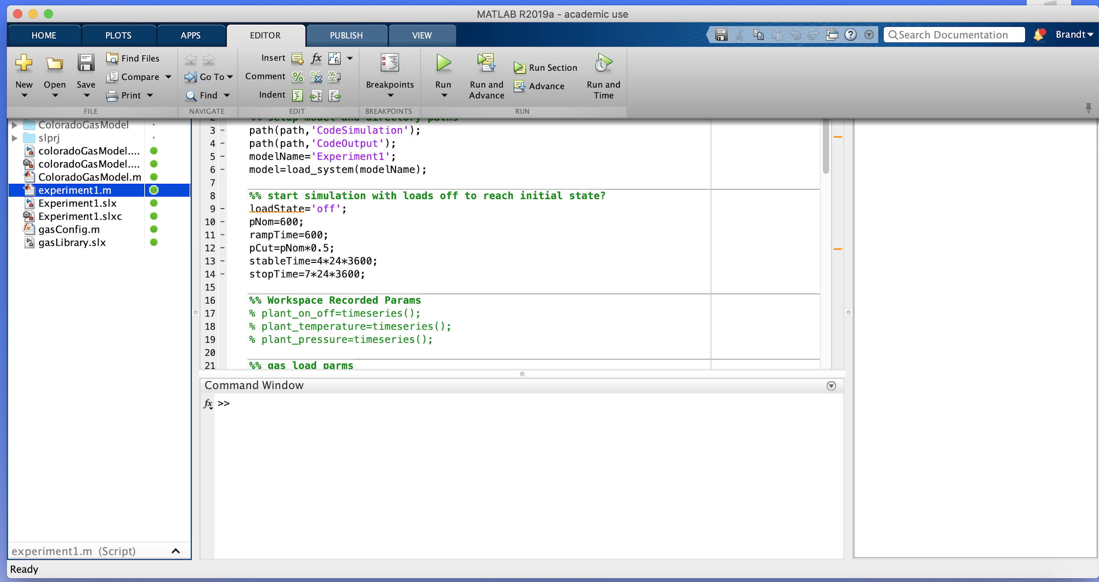

1. Once you’ve run the experiment1.m script you should open experiment1.slx to open up the model.
   1. From here you can click the play/run button to run the simulation

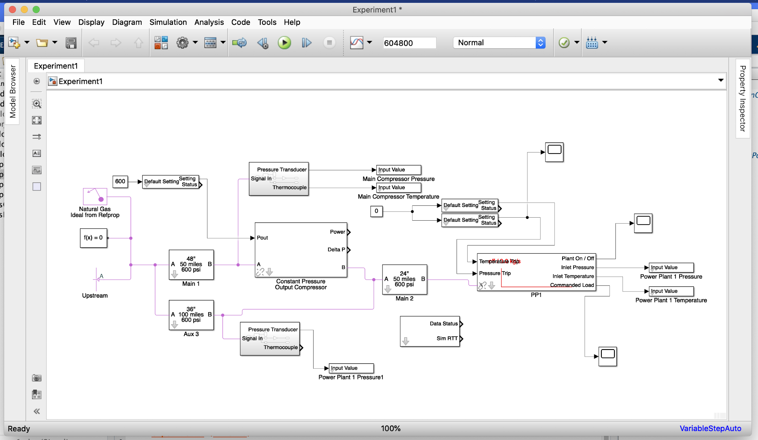

1. After the simulation has run you’ll see the simscape results explorer again.
   1. This will show you all the data you’d need to know about the simulation.
   2. For example if we wanted to check the pressure at Main 1 on the B end.
      1. Select Main 1 → B → p (for pressure)
      2. Then change the units to psi on the left side of the chart
2. Congrats! You’ve run your first simulation.
   1. Since we haven’t added any control interaction yet this isn’t quite the most exciting.
   2. Next, we will look at how to set up the Simulink interface for experiment 1.

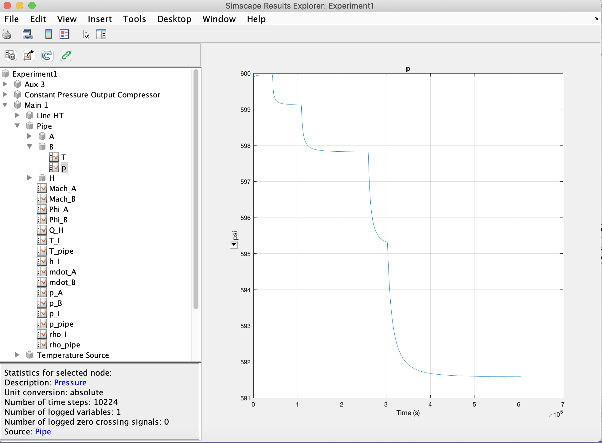

# Setting Up the Simulink Interface For Experiment 1

The Simulink interface allows us to “bolt-on” a Modbus interface to our Simulink process simulation. We are able to create virtual PLCs which can respond to Modbus read and write requests and have those controllers interact with the simulation using our Simulink interface.

1. To start with you will want to open Github project in PyCharm or IntelliJ
   1. These are available with a student license
   2. PyCharm has a free version if you don’t want to deal with the licensing
2. You should be prompted to install from the requirements file
   1. If not you can run `pip install -r requirements.txt` to install the required packages
   2. The current system is running with Python 3.6.1

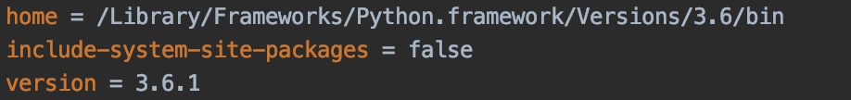

1. Open up your run configurations and we’ll create a configuration for running the Simulink interface
   1. The main is located in model.simulinkinterface.main
   2. The main takes two parameters
      1. -c / --config: which is the location of the config/model specifying the file
      2. -p/--port: is port number to use for sending requests from the Simulink interface
      3. You can also run with --help to see a description of the parameters

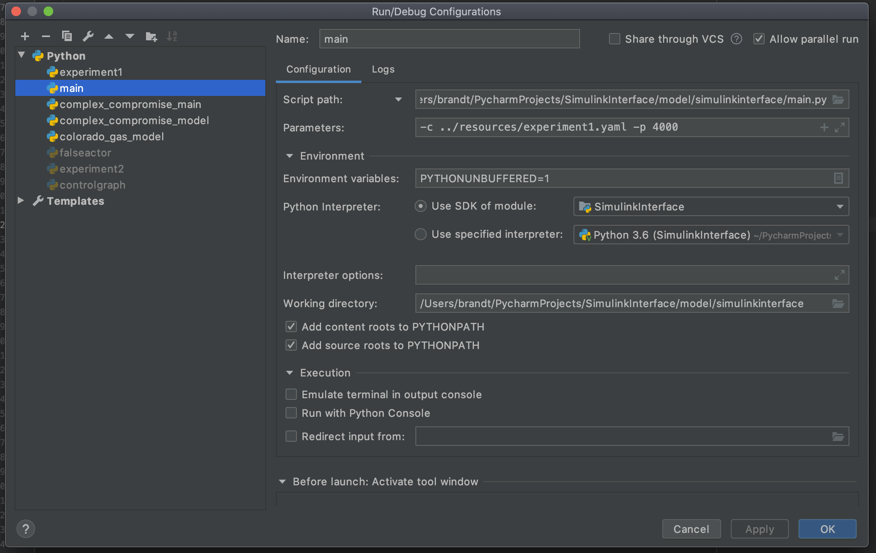

1. You also want to check “allow parallel run” so that you can run the interface and then the controller
   1. For the config file model.resources.experiment1.yaml
      1. The relative path from main will be ../resources/experiment1.yaml
   2. For the port, you can just use 4000
2. After you have set up this configuration you should able to run the main
   1. When running the main you should see a print out of the one compromised controller in experiment 1 simulation
3. Next thing to do is set up the controller
   1. The controller acts as a gas system operator adjusting the pressure settings in experiment 1
   2. We will run the experiment 1 controller for the basic simulation
4. Let’s create another configuration for the experiment 1 controller
   1. You can use a module or script path to specify the file you want to run
   2. The experiment 1 controller is in controller.experiment1
   3. The only parameter is a single argument
      1. This points to the same experiment 1 .yaml file as the main
      2. We’ll talk about how to make these files in a later chapter

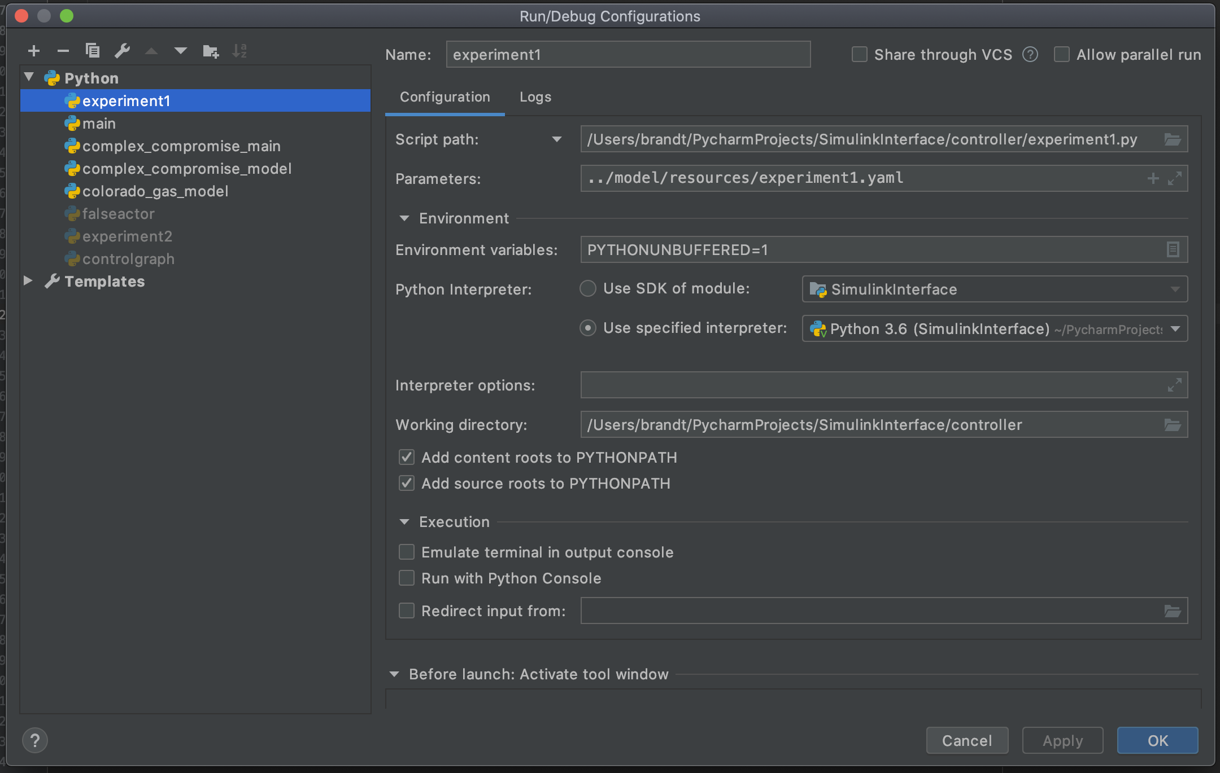

1. Once you have this running you’ll be good to run the physical simulation from MATLAB
   1. Things must be run in the following order: main → controller → physical simulation
   2. Since the main listens for data from both the controller and the physical simulation it must be started first, and the controller will not act until the simulation time from the oracle.timer is greater than 0
2. After running you should see a graph pop up in IntelliJ in the figure viewer
   1. This figure will show you data about the simulation from the controllers perspective

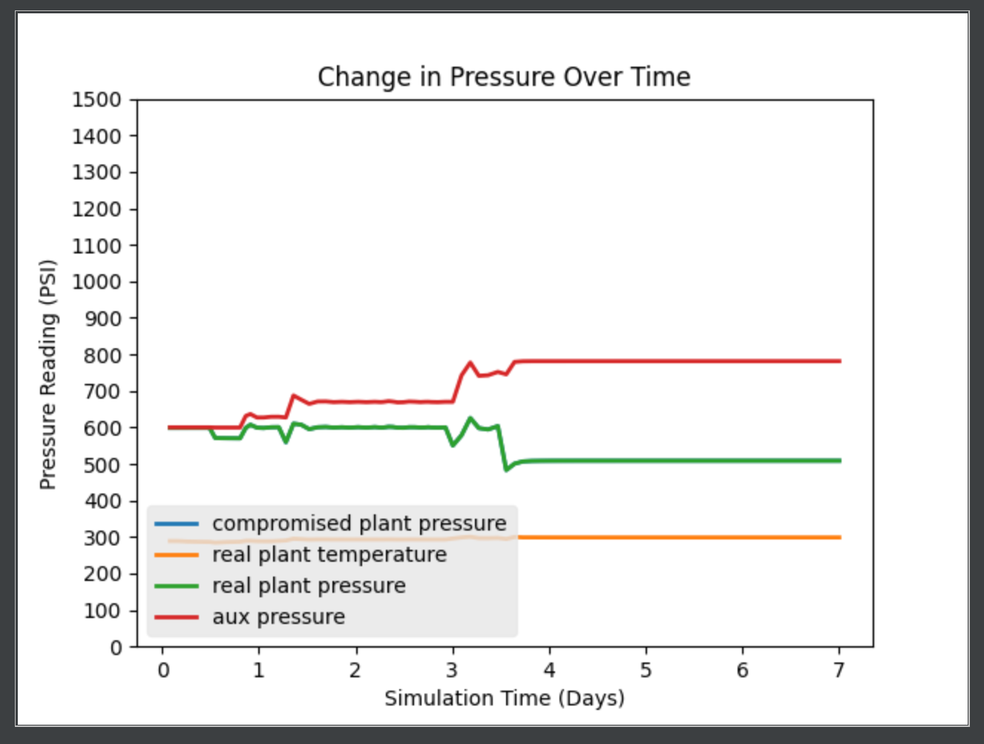

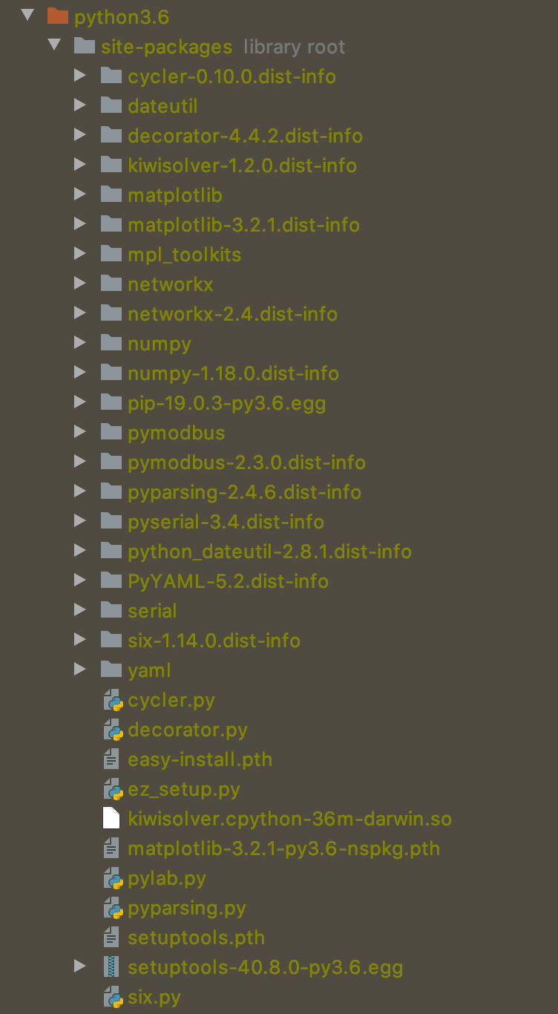

# Understanding the Controller and .YAML Specifications

### Understanding Controllers:

Remember that in our model a simulation consists of three main parts. A physical process (Matlab), a SCADA network / controller later (the simulink interface and it’s virtual controllers), and a human machine interface or control system operator. In our system, we simulate the behavior of this control center by writing code that makes decisions that would act like a system operator. If the pressure is too low then increase the power of upstream compressors, if it’s too high then decrease that pressure. These controller behaviors are modeled by scripts in the controller module. The two main ones we use are the colorado_gas_model.py and the experiment1.py. To go along with these controllers there are some utilities that make it easier to write your own controllers, these are: sensorbus.py and datacollector.py. You already ran the experiment1.py for the experiment 1 simulation. The Colorado gas model one works similar. The main point is that you can write your own controllers fairly easily if you look through the code for these two examples. A lot of the source is redundant but usually follows a set of steps.

1. Initialize the worker_info and sensor_bus stuff
   1. These will make your life easier by having registers in a dictionary
   2. The sensor bus will deal with all the modbus communication for you
2. Do some sort of repeating loop where you do the following
   1. Sleep for some amount of time (to slow down the reactions of the controller)
   2. Call the sensor bus to get all the readings from the controllers
   3. Make sure that the oracle.timer (sim time) is greater than 0
      1. If it is than set the sensor_bus.started to true so it starts collecting data
   4. Reference whatever readings you need
   5. Make a set of actuator updates based on the data you’ve read
      1. Triplets in the form of
         1. PLC name
         2. Register
         3. Value to write
   6. Push these updates to the sensor bus
   7. If the sim time exceeds however long your simulation is then break out of the loop
3. Once your control loop is done you can get all the previous readings through the data collector located in the sensor bus
4. You can tell the data collector to plot things by using its add_to_plot function
   1. You pass it the name of the sensor you want to display for y
   2. Over the sensor you want to display for x (usually oracle.timer)
5. Once you’ve added everything to the plot you can display it with data_collector.show_plot
   1. Make sure that the legend labels are in the right order
   2. You can also save the plot to a file by passing a string to the save_as parameter

### Creating your own .YAML files for your Simulations

The main configuration for the simulink interface and controllers are .yaml files located inside of the model.resources directory. These files specify which PLCs have which workers and information about those workers. At the top level there are names of PLCs. Underneath each PLC there is a modbus port and a list of ‘workers’. Workers are either sensors or actuators, however in the case of the oracle there is also a timer worker. Each worker has a type which currently is “DefaultSensor”, “DefaultActuator” or “Timer”. Sensors listen for data from the simulation on the publish subscribe queue, while actuators send data back through the interface in order to modify the running simulation. The timer communicates with the simulation in order to get the current sim time and determine the round trip time delay. Each **sensor** has: a port that it will check on the publish subscribe queue for new data, a register (which corresponds to its modbus register in the PLC), and can be marked as compromised. Each **actuator**: has a modbus register to be written to from the outside world and a respond_to field which contains a host and port. Usually this will be localhost if running the simulation on the same machine, and then the port of whatever UDP receive block in the simulation you are writing to.

You can mark any sensor as compromised. This means that you want any readings that it gives off to any modbus queries to be modified. When marked as compromised there are 3 main attributes: hold_back, after, and reading. Hold_back is used to delay a signal by some number of readings. So if set to 360 it will give the reading at time *t* - 360 instead of the reading at time *t.* After is used to specify when the compromise should start, standing for “after how many simulated seconds should the attack start”. Reading is the parameter used to actually modify the reading. It can take equations of two variables *x* and *t*, where *x* is the original reading from the sensor and *t* is the simulation time in seconds. So if you always wanted the simulation to read 100 less than its original reading you could set reading to x -100. If you wanted the reading to steadily decrease over time you could have it be *x* - *t / 60* or something like that.

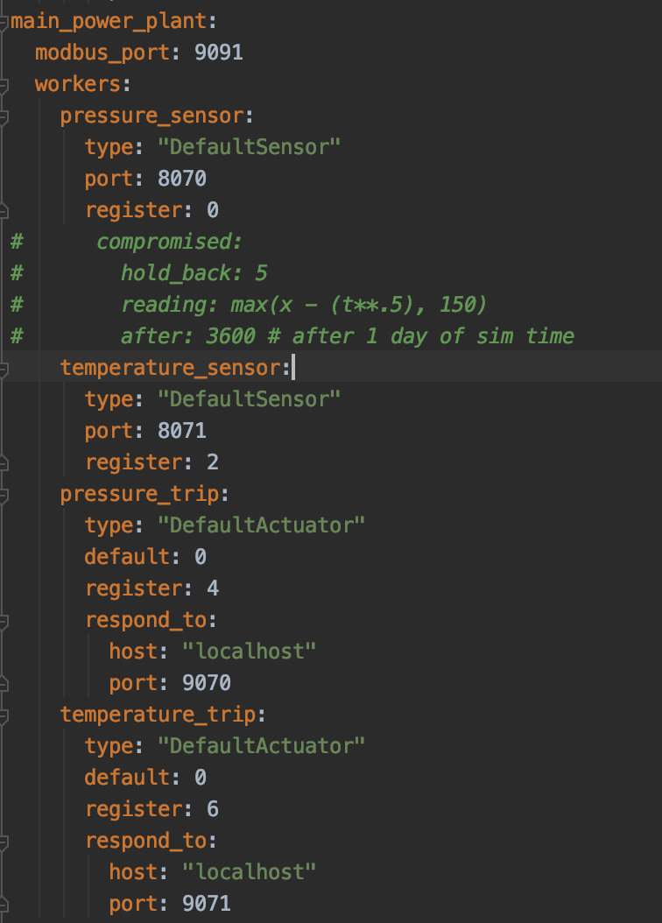

# Modifying Simulink Models to Create Your Own Simulations

Likely the most difficult part of developing simulations is creating simulink models that can demonstrate the dynamics of these complex gas systems. Luckily many of the needed components are already available due to our gas library. When developing simulations there are two main phases you need to consider, an initialization phase and the actual run of the simulation. As these gas models are built on some fairly complicated math there, it’s not always as simple as telling the system to run and it runs. The systems of differential equations sometimes have to reach a stable set of conditions so that can continue to be solved under different variations in the gas model. This is why we have an initialization phase. The best way to develop this phase is to copy and paste one of the existing examples and make changes to it, rather than try to write it from scratch. But for the sake of understanding let’s discuss the steps of how the initialization (.m scripts) usually work.

1. First these scripts will import and functions that they need
   1. In the Colorado gas model this means adding the ColoradoGasModel directory to the path
   2. The ColoradoGasModel directory contains code for adding loads, pipes, and other system components
2. Then there will be an initialization of some important system wide variables
   1. modelName is the name of .slx simulation file that will be run
   2. stableTime is a variable that specifies how long the simulation will run in its start up condition
   3. stopTime is the amount of time we want to run our simulation for
   4. systemPressure is the nominal system pressure
   5. shutOffPoint is the pressure reading at which power plants will shut off
   6. shuttOffDuration is how long power plants will shut off before turning back on
3. Next there is the process of grabbing the configuration for the model
   1. gasLine and gasLoad parameters are functions defined in the ColoradoGasModel directory
   2. These functions specify the names and values for each line and load and stuff them into a matlab style table
   3. The gasConfig contains some properties of natural gas and you probably don’t want to mess with it unless you understand what they mean
      1. Ask Dan Zimmerle at the CSU power house for help if you need to understand this
   4. The system load is specified in loadParm row 1, this is the profile that will be distributed amongst all loads in the coloradoGasModel
4. After all the initial configuration and parameters are set up we make our first pass of simulation
   1. During this pass the loadState is set to ‘off’ meaning that the loads will not consume any gas
   2. Basically the pipes will fill up with gas and everything will get setup but no loads will run
   3. Note that for this to run simscape operating points must be turned on as well as simulation logging, we’ll talk about how to do that in a second
5. The second pass is similar but the loads are set to initial which is just a light load to get everything ramped up and primed

### Turning on Simulation Logging and Operating Points

If your model is failing the initialization for inexplicable reasons it could be because the simulation logging and operating points are disabled. To enable them, open up the .slx file for your simulation model and click on the gear in the toolbar. Then select Simscape and you should see opens for log simulation data, which should be set to all, and make sure limit data points is disabled. I always name the simulation logging variable `simlog` but you can name it however you like. Next make sure operating point initialization is enabled, and I always name this variable `op`. Operating points are how simulink saves the state of the model so that it can be run repeatedly after that initialization phase.

You can always access data from the simlog in the matlab viewer if you have a handle on the simulation object. So if you run a simulation like such:

s = sim(modelName)

Then the simlog will be located inside of `s.simlog` or whatever you named the variable if it’s not a simlog. Remember that simulations can be run by calling `sim(modelName)` and also by running from the model viewer with the play button. However, I don’t believe that running from the model viewer will save the simlog in a simulation object like running with the previous approach.

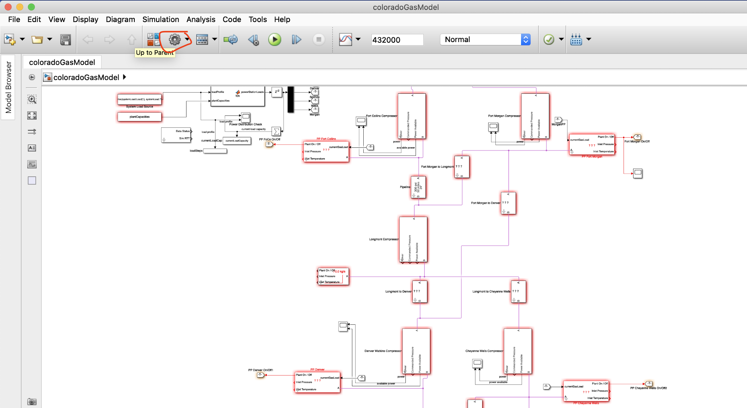

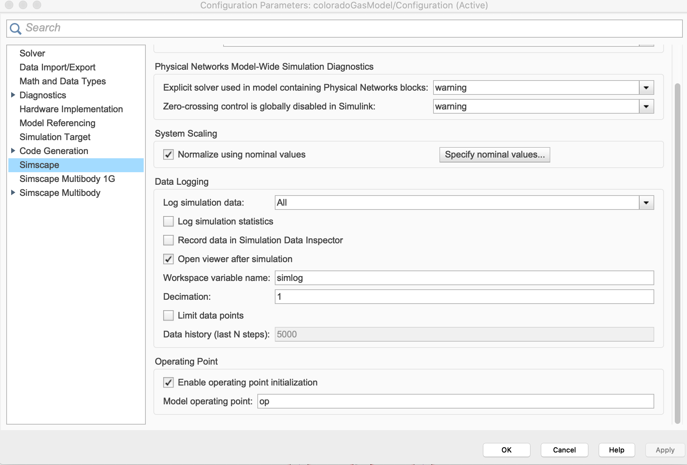

### Adding Blocks from the Gas Library

If developing or modifying simulations you’re going to want to know about and use our gas library that contains a lot of the matlab code and simulation blocks we have already written. To access the library you can click on the gasLibrary.slx file in the model viewer or select any one of our home baked blocks and use: Command + L on Mac or likely Ctrl + L on Windows. This should pull up our library of blocks. Within this library there are a lot of components so let's go through them 1-by-1. If you ever need to edit a block you must click the small lock in the bottom left to “unlock” the library and allow changes. If you want to go underneath the mask (see what’s inside a block) you will also have to disable this and click on the little arrow in the bottom corner of a block.

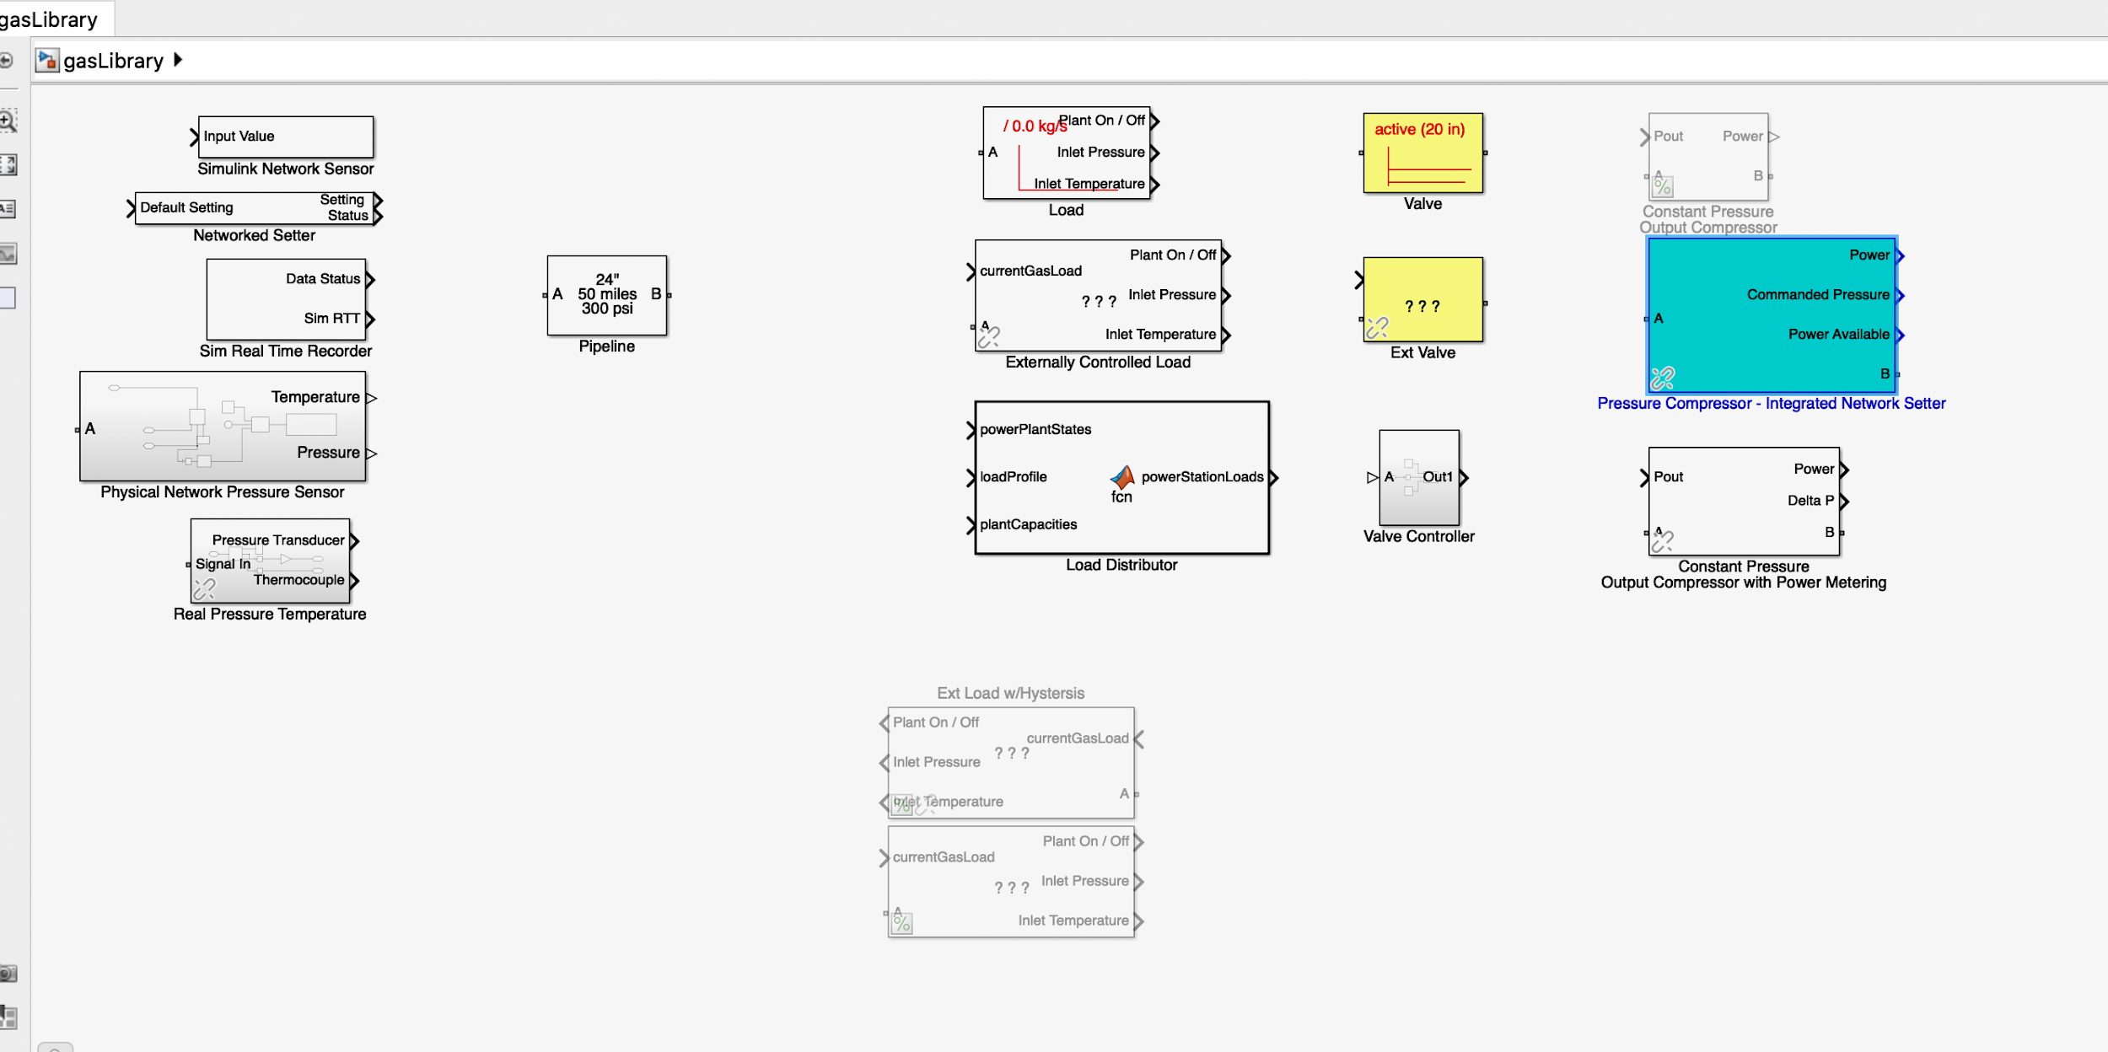

#### Simulink Network Sensor

The network sensor is used for sending data out of the simulation to the interface or virtual PLCs. This block samples the current input value and time, muxes them together and then sends them over a UDP send block to whatever port specified. The UDP send port is set to non-blocking. It is also possible to use TCP to interface with the simulink interface but much of the code in the interface has moved past that at this point. However, you can read through the source and uncomment some stuff if you want to try it.

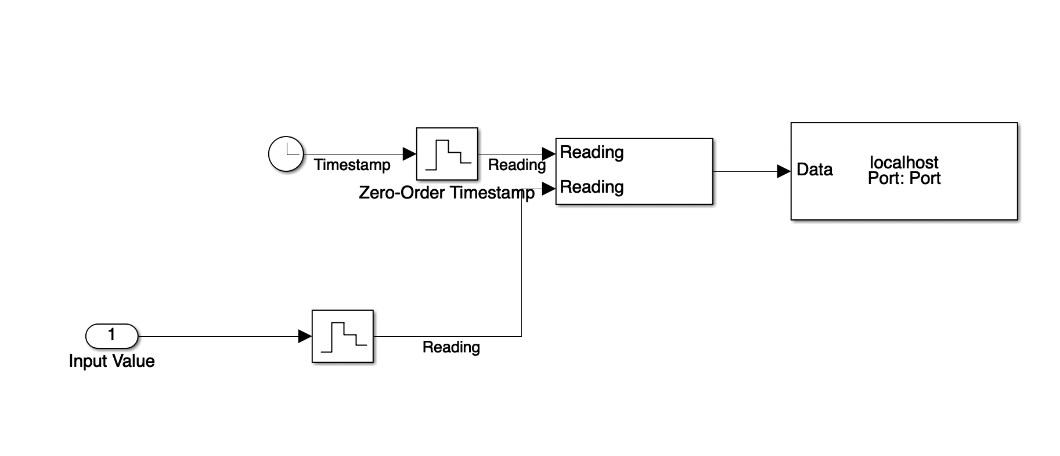

#### Networked Setter

This block is kind of the inverse of the network sensor. It acts like an actuator into the simulation. In some sense the `Simulink Network Sensor` correlates to the “DefaultSensor” worker and the `Networked Setter` correlates to the “DefaultActuator” worker. This block receives data over UDP, but also has a default setting for if / when it doesn’t receive any data. This means that the simulation can be run without the interface if needed (one advantage of using UDP over TCP).

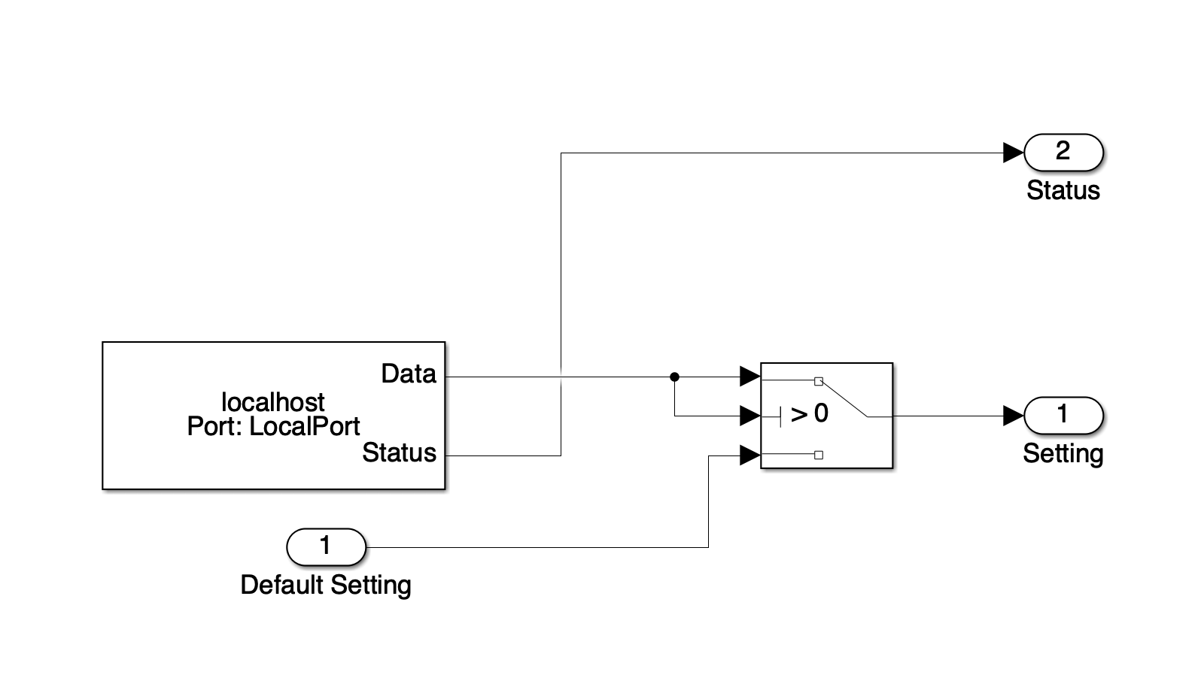

#### Sim Real Timer Recorder

This is the other half of the “Timer” worker in the simulink interface. This block sends out the current simulation time along with repeating the last real-time measure received from the timer worker. This creates a kind of loop where the Simulink timer and the interface timer are informing each other of their concepts of time. Allowing us to determine the ratio of simulated to real time, and also the round trip time delays if needed.

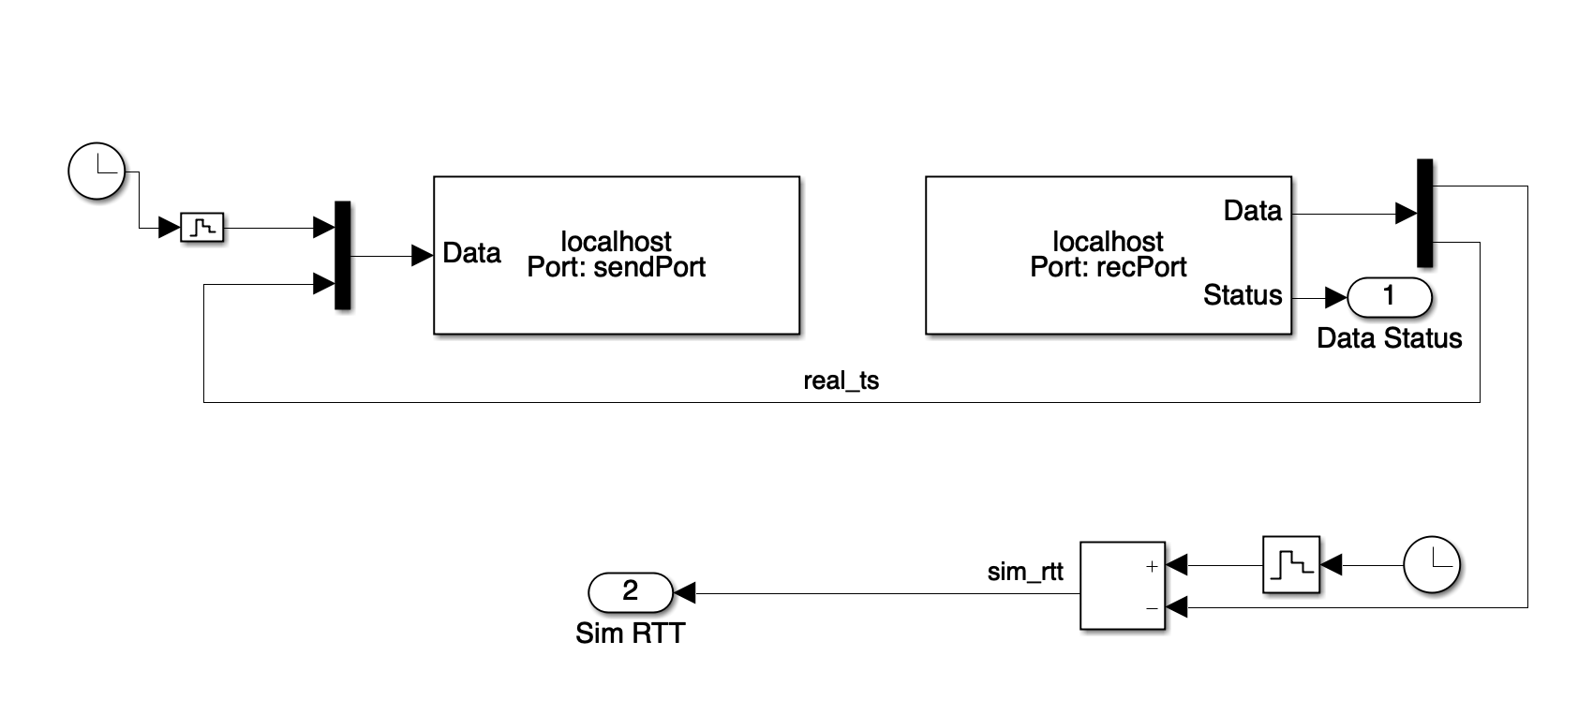

#### Physical Network Pressure Sensor

This one’s rarely used but can be modified as a combination of the network sensor and real pressure recorder, you can look inside it and change it if you’d like but it’s not currently used in any of the models.

#### Real Pressure Temperature

This block doesn’t involve any networking but it is critically important. This block converts signals from the simscape format into simulink signals that can be sent out with the network blocks. Simscape has a special way of doing it’s “lines” which carry several pieces of data about gas flow, temperature, pressure, and some other physical properties. To extract just temperature and pressure these need to go through a block called a “Pressure & Temperature Sensor (G)”. To simplify this process I created a block that takes in a simscape line and spits out it’s pressure (in PSI) and temperature (in K) so that you can easily pull the pressure and temperature off any line in the model. This is usually the first step before sending something out with a network sensor.

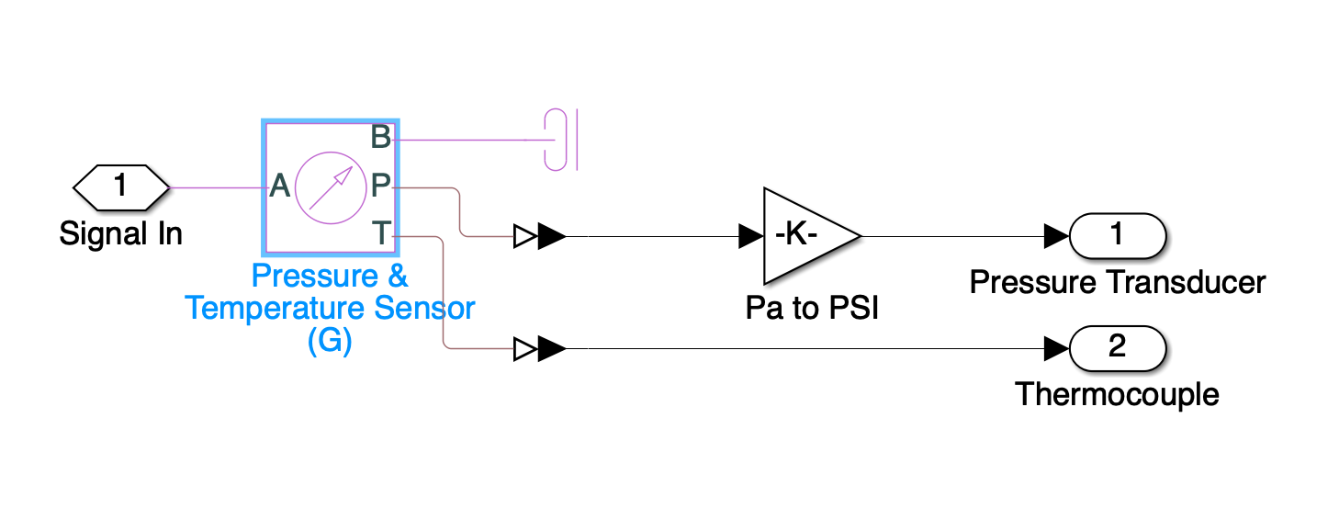

#### Pipeline

These blocks are used to specify a length and diameter of pipe using some physical dynamics. Their configuration/properties are set inside the initialization part of the simulation which we’ll go over later.

#### Load

The most basic load type block. This one has its own switching off / back on methodology using a pressure cut off. This load's properties will be specified in the configurations as well. It is important to note that this style of load will switch off at the cut off point and then switch back on at some other switch on point. Inspect the hysteresis block within it for more information.

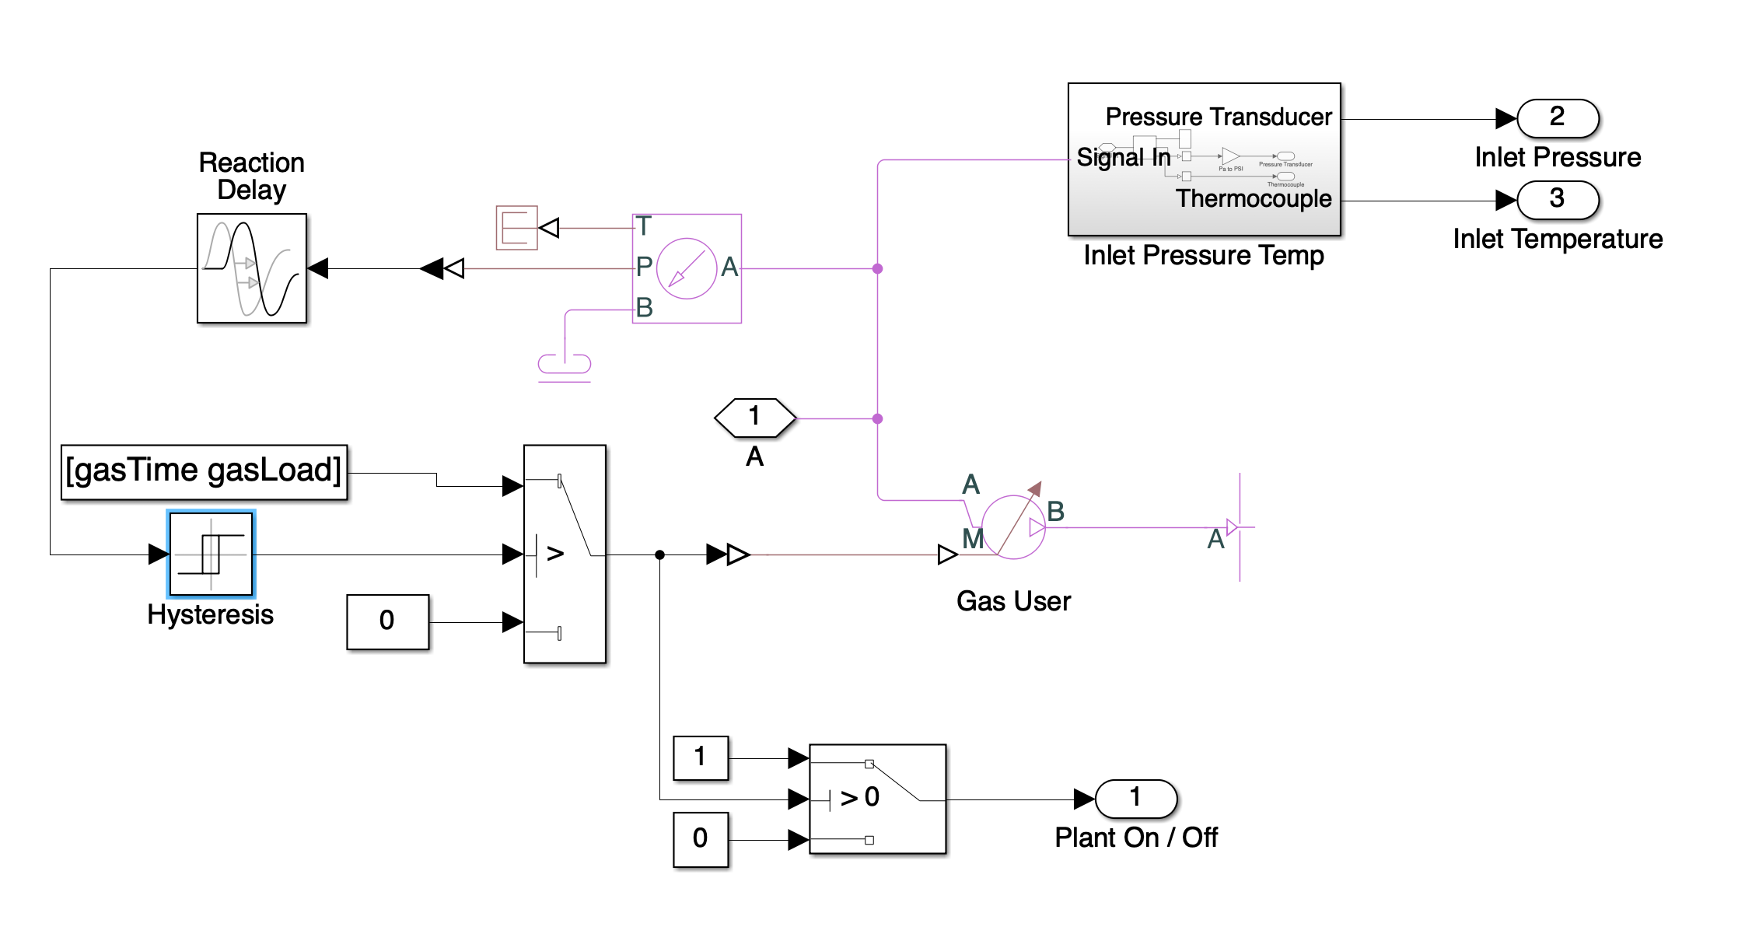

#### Externally Controlled Load

These are the loads used throughout the Colorado Gas Model. They still have some parameters (like their load name) being passed through the configuration but for the most part are managed by external signals. The pressure shut off matlab function deals with shutting off the block when pressure is too low and can be fiddled with to include temperature if needed as well. You’ll have to go into the matlab function and write some code though. This load basically consumes gas based on an input signal it gets, and has a switch on/off so that if it is switched off it will consume no gas. These are used in combination with a load distributor so that loads share a common goal of generating some amount of power.

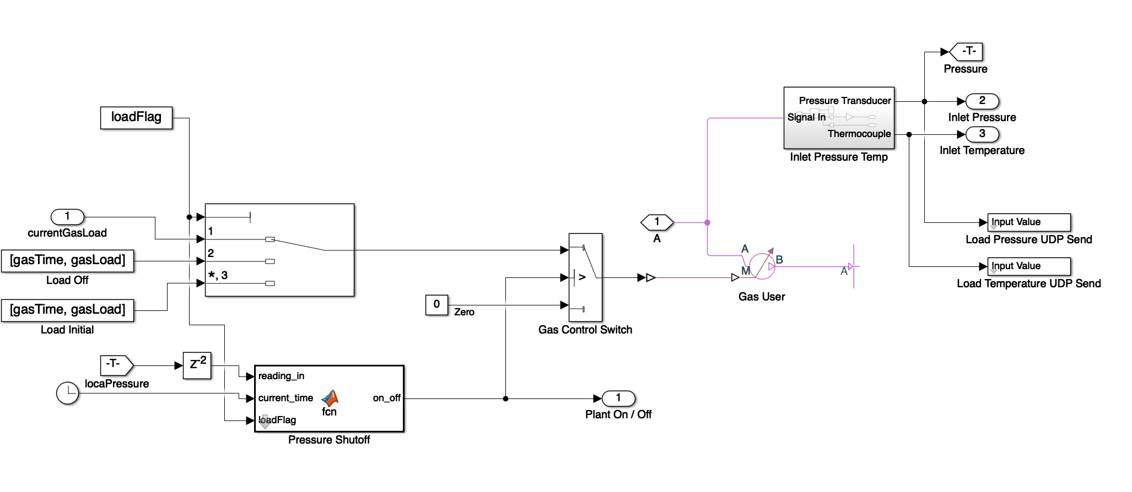

#### Load Distributor

This block is a matlab function that takes a load profile (the total system load), a list of plant capacities, and a list of plant states and determines how much load each plant should get. So this function is sort of a feedback loop that distributes the current load amongst all the available power plants. To see its usage you can look at the coloradoGasModel.slx. You’ll want to mux together all the power plant states, and then demux all the loads on the way out. These will come out as a vector so make sure that the plantCapacities and powerPlantStates are all ordered the same.

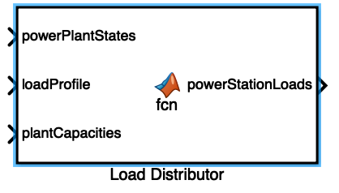

#### Valves

We haven’t messed with using valves in any of our current simulations but they should be simple to figure out using a networked setter and networked sensor if you’d like to create a valve that opens and closes a gas line with external control from a PLC / Virtual PLC. Look under the “ext valve” block to get some basic inspiration. Basically I think the AR has to do with the area or diameter of the pipe available so you can in theory kind of “half-close” a valve. Usually you can just use something between the range of 0 - 1 and multiply it by Dmax (the diameter of the pipe) and that should get in the right direction.

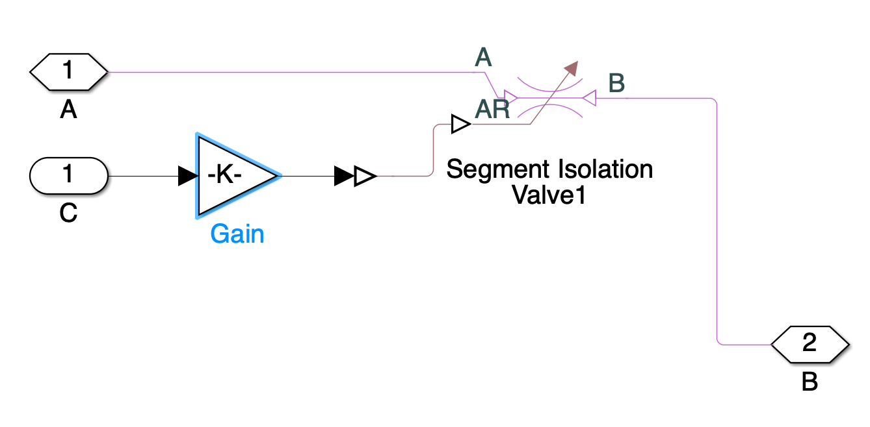

#### Compressors

We have two types of compressors that aren’t commented out. The “Constant Pressure … with Power Metering” is a gas compressor that takes a pressure set point (Pout) and tries to compress gas to meet that set point. The “Max Power in Megawatts” is used to dampen how much gas is compressed by adjusting delta p. This means that the compress will only compress as much gas as it is able to given a certain amount of power. This is an upper limit and the compressors ability. If you look at the power out then, it is likely that this will never really exceed (by much) the power specified. This is because delta p is adjusted so that the power you can compress is never really exceeded. If you think our compression efficiency is off you can mess with the power transfer function, but this is mostly engineering stuff that’s quite complex and may be best to consulate with an expert in either simulink or gas systems to understand it better.

The other compressor is the same as this power metering one, except that the max power can be adjusted by an outside controller. This allows a feedback loop where you can have operators adjust the available power to compressors to meet gas demand, and then have them ramp it back down later so power is not wasted. This is the main source of control in the colorado gas model. Look at the network setters in the other one to see that the pressure set point and max power can be adjusted.

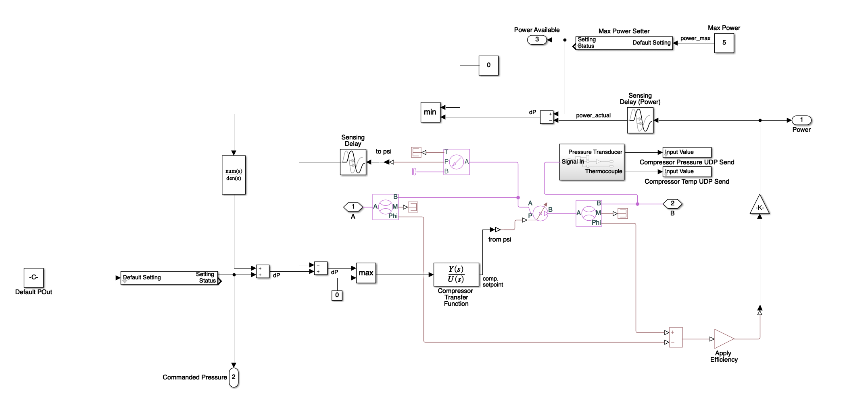

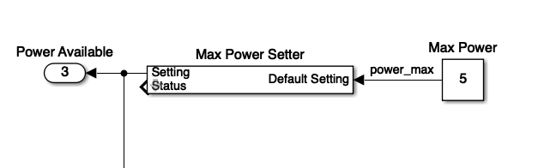

### 

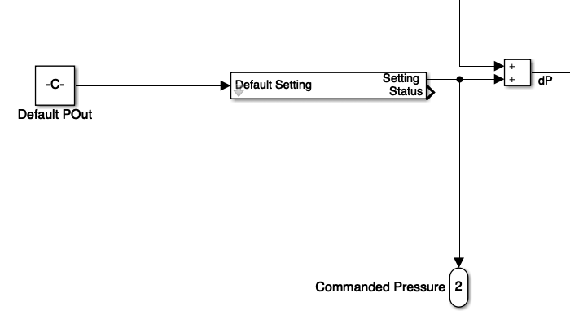

### Editing the “Mask”

Many of the blocks in the library have “masks” which is a Matlab term that allows you to set some parameters for a block and “promote” anything in your blocks you want to set as a parameter. For example our externally controlled load has a lot of parameters when we click on it. This thing is called the mask. It can be edited by clicking on the block and doing ctrl + m, or by right clicking and selecting mask -> edit mask. Within the mask you can adjust how the block is displayed, if it has an icon or a graph, what the data inputs should be labeled. There is some section for block initialization where you can write matlab code to set some variables in the block. Mostly what you’ll use is the “Parameters and Dialog”. On the left hand side you’ll see form elements you can add, and the one we want to talk about right now is the “Promote”. This allows you to pull up parameters from other blocks within the subsystem. You can double click promote to add a new promotion, then on the right hand side where it says “Type Options” you can click “Promoted Parameters”. This will bring up a list of all the blocks within your subsystem select a block and a parameter from this block, you can then transfer it over with the arrow button. This will allow you to specify certain parameters at the top level instead of having to manually change each block. For example, if you added another network sensor to a block and want to be able to specify the port number on the top level.

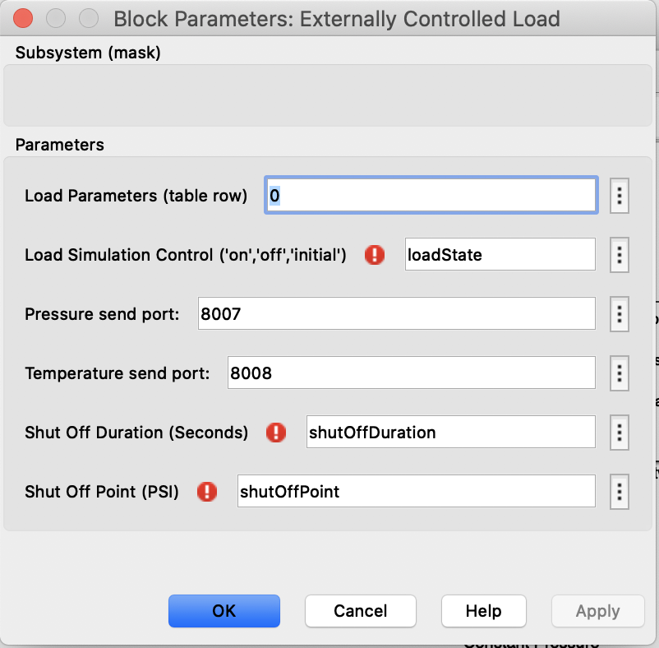

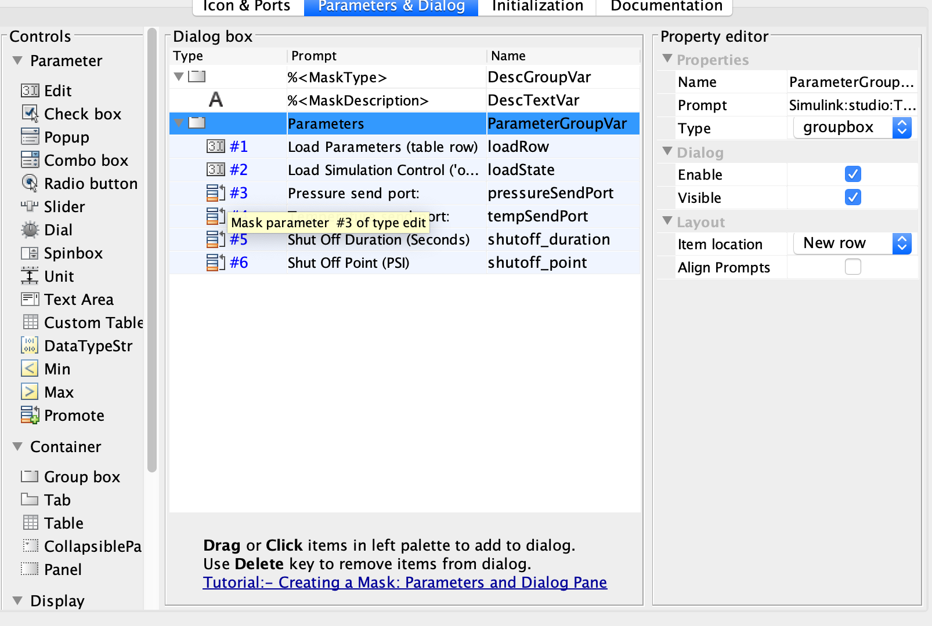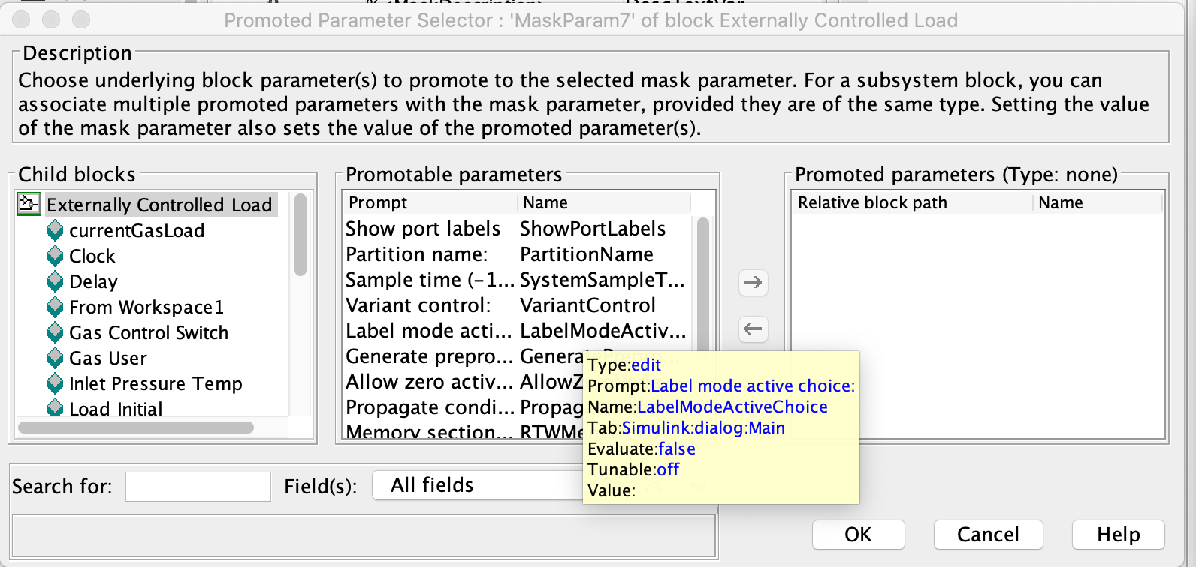

### Understanding the Configurations of load and line parameters

When developing your own simulations, you will have to set up the configurations for the gas loads, gas lines, and any valves within the matlab initialization script. This can be done in the main script (like Experiment 1), or using a separate directory of matlab function scripts (like the Colorado Gas Model). The matlab functions that are needed if using the second approach are the gasLineParameters, gasLoadParameters, and gasValveParameters.

#### Gas Line Parameters

The code for gas line parameters is fairly straight forward. First we initialize the nominal pressure we want to use for our gas lines, passed as a parameter into the function. Then we create each gas line one by one using the function add_to_line defined as a subfunction. The add_to_line creates a table with data about the pipe and its attributes, which are assigned to each pipe upon initialization. The diameters of each pipe must be sized to meet the demand of downstream demand. This is discussed in the thesis dissertation, but you can reference the pipe diameters in the git repo to get an idea of how big a pipe needs to be for different gas loads. Note that in later simulations it would be a good idea to use multiple small pipes since real gas systems do not always use large pipes.

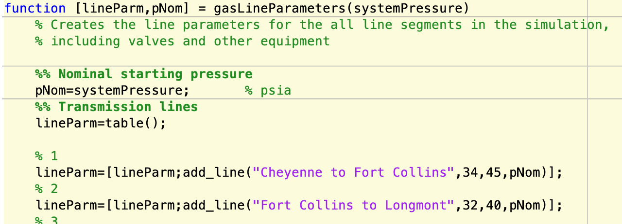

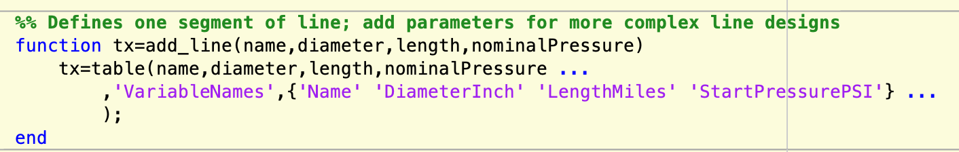

#### Gas Load Parameters

The code for gas load parameters is similar to gas lines, and is extremely essential. The primary difference in this code is that if you are using a system wide load (for dynamic load distribution) then it is a wise idea to put that system load as the first load in the table. At the beginning of the function we initialize a few constants, the most important are pNom and rampTime. There is a pCut and pressureCutOff but these are only used in simple loads that use a hysteresis block for shutoff rather than the matlab function that is written for the more sophisticated loads. Each load consists of a set of ramps, a ramp is just an adjustment of gas demand over an amount of rampTime. So creating a load is a combination of using the add_ramp function and the add_load function. First you create a set of ramps by appending them to a table. Then you use the add load function with which takes 4 parameters: the name of the load, the table of load ramps, pNominal, and pCut. Note that when using the systemLoad, all other loads just need a dummy set of gas pressures since they will be taking their load as a proportion of the system load. If not using a system load then you will have to manually specify each load for each power plant in a similar fashion to how the system load is specified.

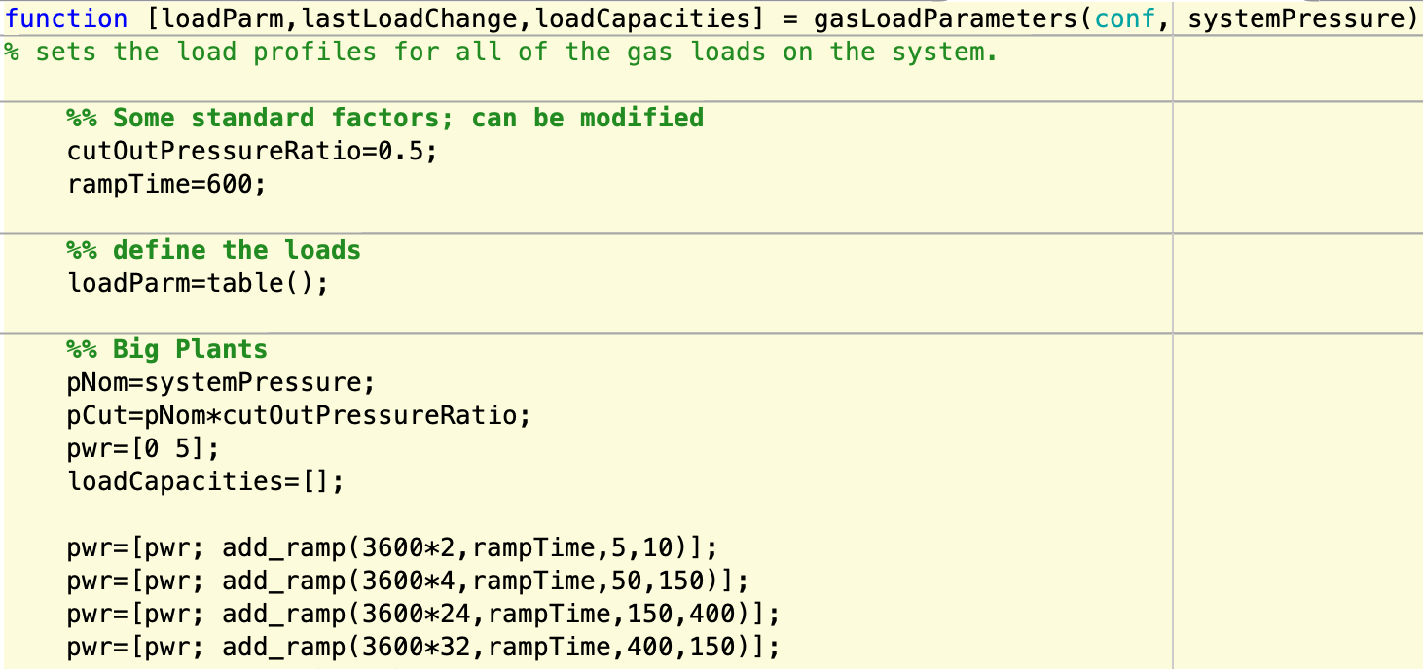

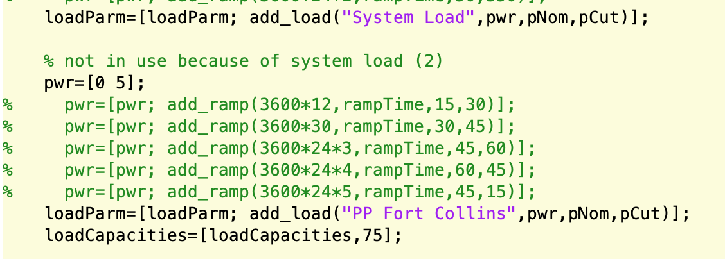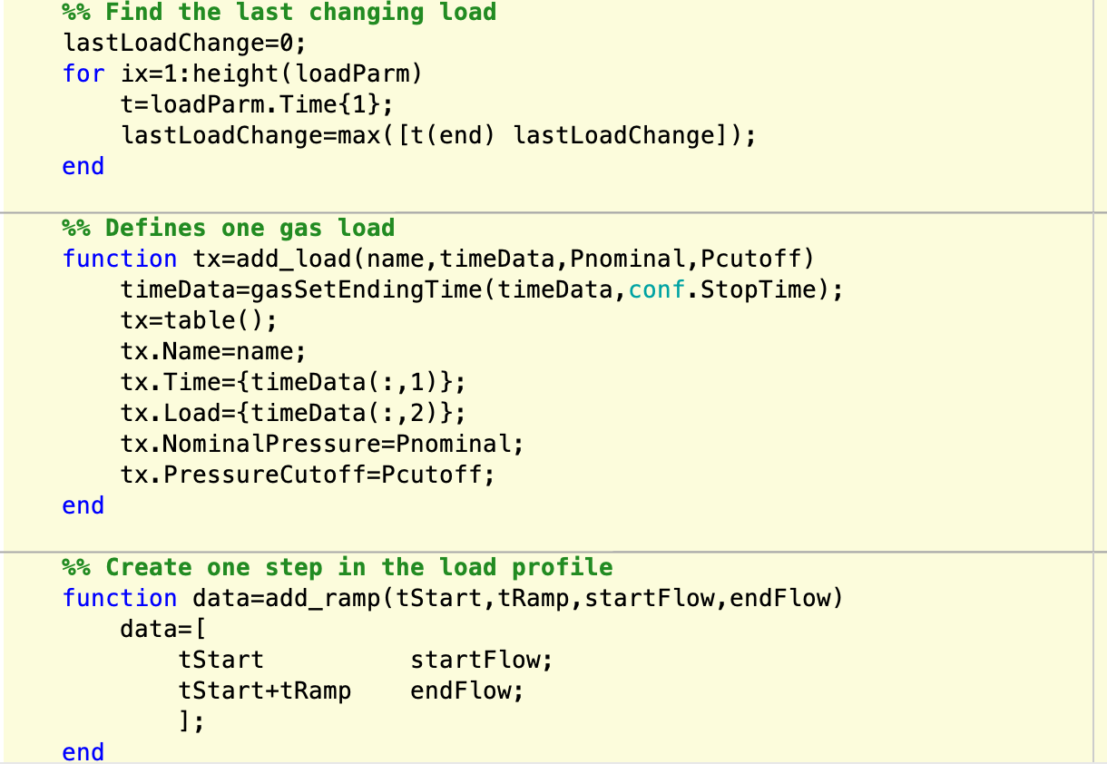

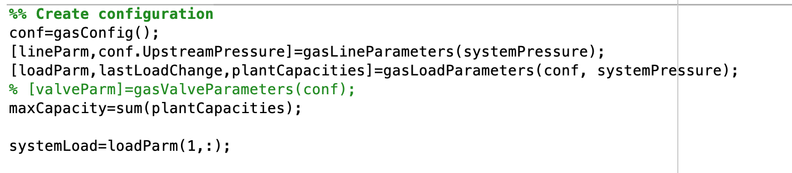

#### Valve Parameters

Valve transitions are similar to gas line and load parameters but haven’t been used in any of our experiments so for. However, their initialization functions in a similar fashion. If using externally controlled valves then these transitions will just be dummy values as you’ll be opening and closing the valves using controllers. Otherwise it would presumably function in a similar manner to adding gas lines or loads to the system.

#### Telling the Simulations which table values to use:

Once everything is initialized using the gas load or line parameters you should have data tables of everything you need for each line and load. When adding a line or load everything will have to be reinitialized. This line or load can then be accessed by the name of the table and index (Matlab indexing starts at 1). For example, in the Colorado Gas Model the system load is the first load in the table so it is accessible at loadParm(1, :). So for each block you will have to pass it’s specific sub-table so that it knows what data is needed for it to initialize its name and place in the simulation.

